H.T No
Regulations:
A20

Sreenidhi Institute of Science and Technology
(An Autonomous Institution)
Code No: 8K404 Date: 17-Aug-2023 (FN)

B.Tech II-Year II- Semester External Examination, Aug - 2023 (Regular & Supplementary)
MECHANICS OF MATERIALS (CIVIL)

Time: 3 Hours Max.Marks:70

Note: a) No additional answer sheets will be provided.
b) All sub-parts of a question must be answered at one place only, otherwise it will not be valued.
c) Missing data can be assumed suitably.

Bloom's Cognitive Levels of Learning (BCLL)

Remember | L1 | Apply | L3 | Evaluate | L5
Understand | L2 | Analyze | L4 | Create | L6

Part - A Max.Marks:20
Answer all QUESTIONS

 |  | BCLL | CO(s) | Marks
1 | Explain longitudinal stresses and hoop stress in thin shells. | L2 | CO1 | [2M]
2 | Explain about strain tensor. | L2 | CO2 | [2M]
3 | What is meant by a neutral plane in beams? | L1 | CO3 | [2M]
4 | What is the moment area method? | L2 | CO4 | [2M]
5 | State Castigliano’s first theorem for strain energy. | L2 | CO5 | [2M]
6 | Write down the relationship between effective length and actual length for different end conditions. | L2 | CO6 | [2M]
7 | State the principle stress theory of failure. | L2 | CO2 | [2M]
8 | Differentiate statically determinate and indeterminate structures with example | L2 | CO4 | [2M]
9 | List out the assumptions made in Euler’s column theory. | L1 | CO6 | [2M]
10 | Define the terms Resilience and modulus of Resilience. | L1 | CO5 | [2M]
Part – B Max.Marks:50
ANSWER ANY FIVE QUESTIONS. EACH QUESTION CARRIES 10 MARKS.

 |  |  | BCLL | CO(s) | Marks
11. | a) | A thin-walled water pipe carries water under a pressure of 2 N/mm² and discharges water into a tank. The diameter of the pipe is 25 mm and the thickness is 2·5 mm. What is the longitudinal stress and hoop stress induced in the pipe? | L5 | CO1 | [5M]
 | b) | Find the thickness of metal necessary for a cylindrical shell of internal diameter 150mm to with stand internal pressure 50 N/mm². The maximum hoop stress in the section is not to be exceeded 150 N/mm² | L5 | CO1 | [5M]
12. | a) | Define and explain types of stresses. Derive an expression for Young’s modulus in terms of bulk modulus and Poisson’s ratio. | L2 | CO2 | [5M]
 | b) | At a section of mild steel shaft of diameter 180mm, the maximum torque is 67.5 kNm and maximum bending moment is 40.5 kNm. The elastic limit in simple tension is 220 N/mm². Determine the weather the failure of material occurs or not according to maximum shear stress theory. | L5 | CO2 | [5M]
13. |  | Draw the sherforce and beading moment variation of given beam.  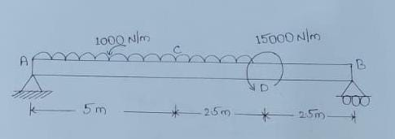 | L5 | CO3 | [10M]
14. |  | Find out forces in all members of truss using method of joints  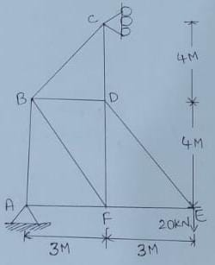 | L5 | CO4 | [10M]
15. |  | Using unit load/virtual work method find the horizontal displacement of roller support. Take E= 210x10³ N/mm².  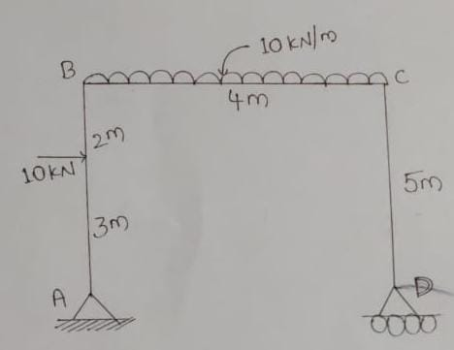 | L5 | CO5 | [10M]
16. |  | Derive Euler’s equation for a crippling load of column with both the ends of column are hinged. | L4 | CO6 | [10M]
17. | a) | Derive the constitutive relationship between stress and strain for three-dimensional stress Systems. | L4 | CO1 | [5M]
 | b) | A cantilever beam of a span 6m carries gradually varying load, zero at the free end to 2 Kn/m at fixed end. Draw the shear force and bending moment of given beam | L5 | CO2 | [5M]
18. | a) | A simply supported beam of span 2 m is loaded with a point load of 20 kN at its mid-point. Find the maximum slope of the beam, if  EI = 500x10⁹ N-mm⁴. | L5 | CO4 | [5M]
 | b) | A hallow circular bar 5 m long and 4 cm internal diameter and 5 mm thick is used as strut with both ends are hinged find the crippling and safe load taking factor of safety 3. E= 2*10⁵ N/mm² | L5 | CO5 | [5M]

-- 00 -- 00 –

